Geoserver Installation Procedure

Install JDK
Download geoserver-2.6.3.exe from Geoserver Official Web sites (http://geoserver.org/download/)
Install geoserver-2.6.3.
Start Geoserver.
Open Geoserver Web admin page from start menu. Login
STEPS for publishing Map Imagery
Geoserver Url
http://41.160.225.20:8085/geoserver/web/

Login : admin
Password : geoserver

Steps for publish the services for LandUseCapture

Open http://41.160.225.20:8085/geoserver/web/ with username and password

STEPS

Click on Workspaces and Add New Workspaces
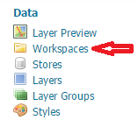

Click on Stores and Add New Stores

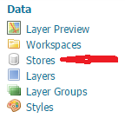

Click on ImageMosaic

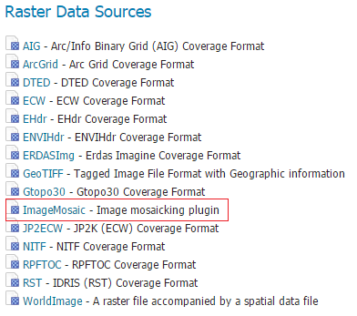

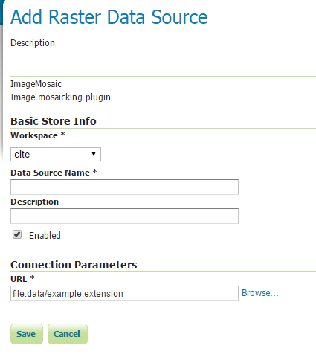
Select Workspaces
Write some Data Source Name
Write Description
Then click on Browse
select drive from dropdown
then from list select folder
then click OK

Then 4 tab will come
1 Data
2 Publishing
3 Dimensinons
4 Tile Caching

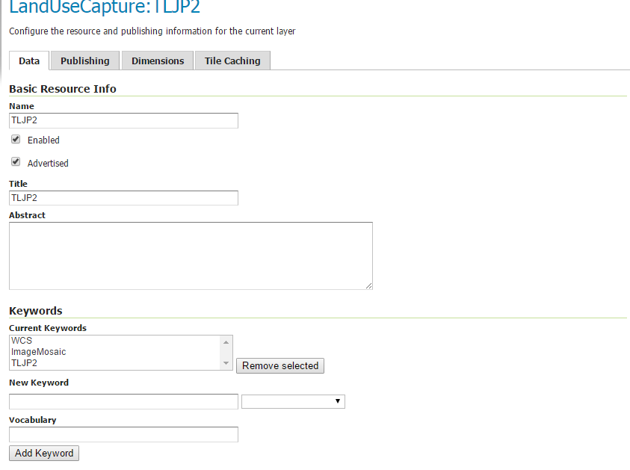
Cache Time (seconds) : 200000
Expire server cache after n seconds (set to 0 to use source setting) : 2000000
Expire client cache after n seconds (set to 0 to use server setting) : 200000

On Tile Caching tab go down click save.

Click on Caching Default.
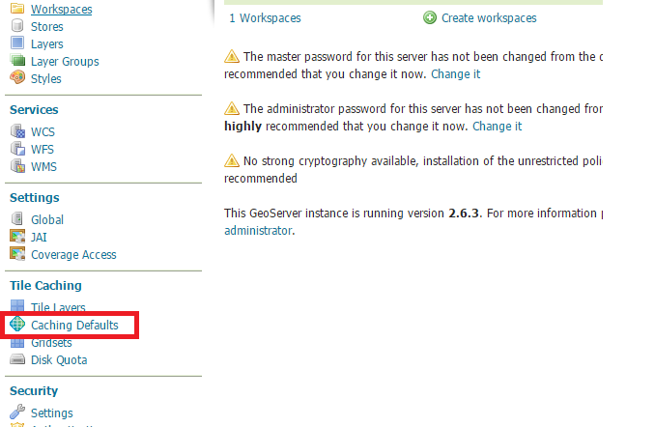
And Configure as par below screen shot.
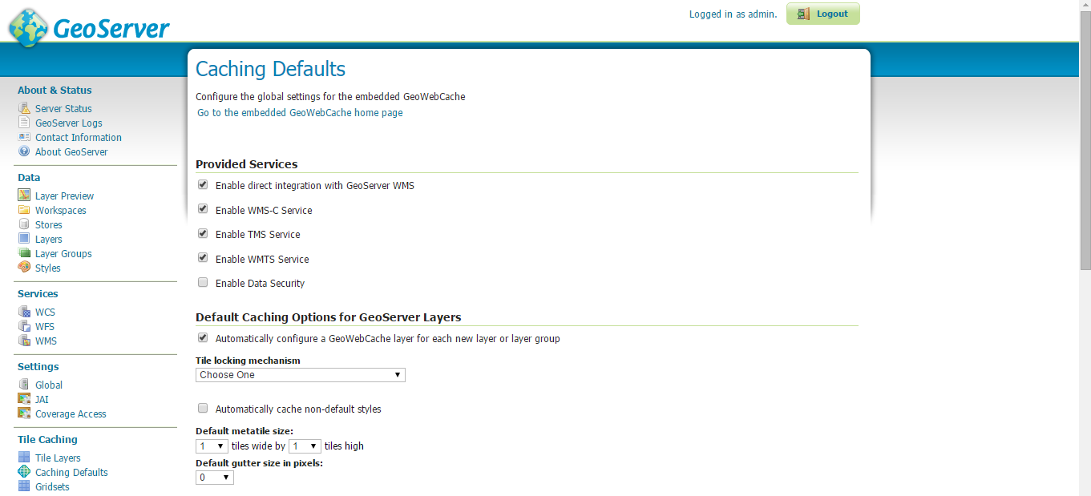
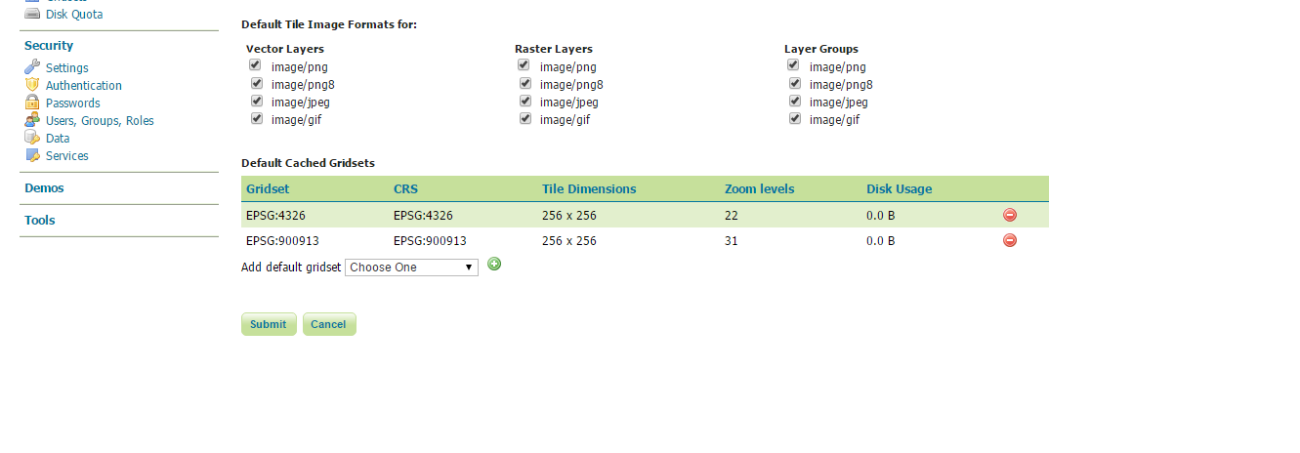

Changing the cache directory
GeoWebCache will automatically store cached tiles in a gwc directory inside your GeoServer data directory. To set a different directory, stop GeoServer (if it is running) and add the following code to your GeoServer web.xml file (located in the WEB-INF directory):

<context-param>
<param-name>GEOWEBCACHE_CACHE_DIR</param-name>
<param-value>C:\Program Files (x86)\GeoServer 2.6.3\data_dir\gwc</param-value>
</context-param>

Steps for ECW Image format
Installing GDAL extension
1. Download http://sourceforge.net/projects/geoserver/files/GeoServer/2.6.1/extensions/geoserver-2.6.1-gdal-plugin.zip
2. Extract the files to C:\Program Files (x86)\GeoServer 2.6.1\webapps\geoserver\WEB-INF\lib

